DBMS Task-2

Date: 22 June, 2021

1. List all media of a particular film.

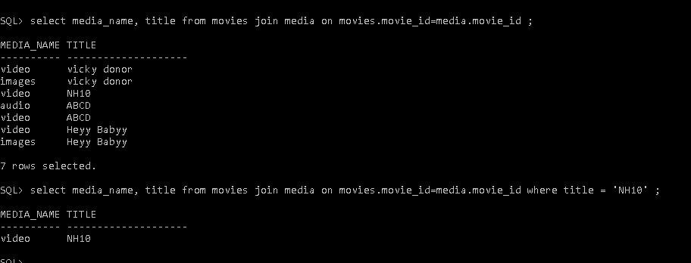

1. List all media and review of a particular film.

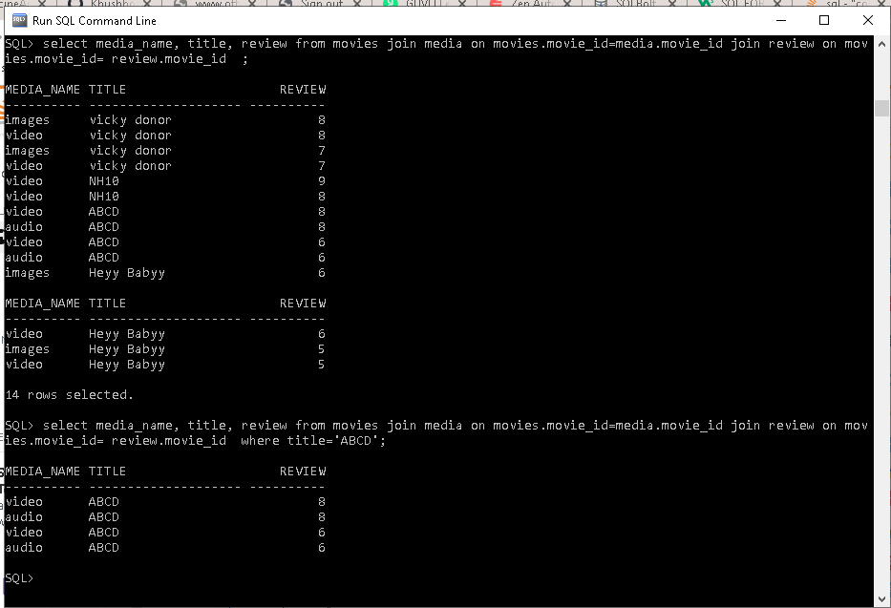

1. List all cast along with roles and artist of a particular film.

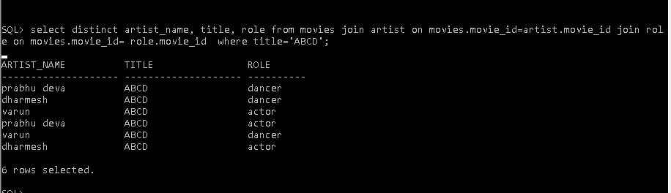

1. List all the review given by particular user

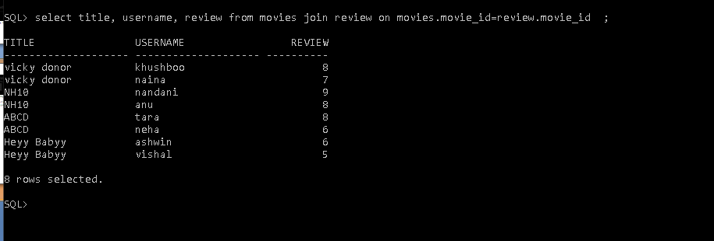

1. List all the skill of a particular artist.

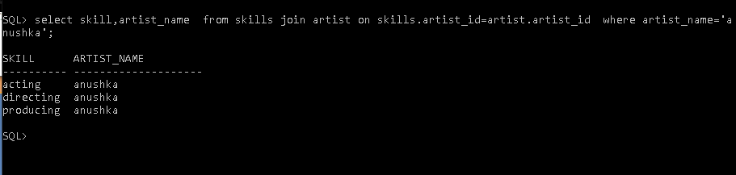

1. List all the roles performed by particular artist.

